vehicle management
21mcme16(V. Madhava Babu)
21mcme26(G. Lokesh Varma)

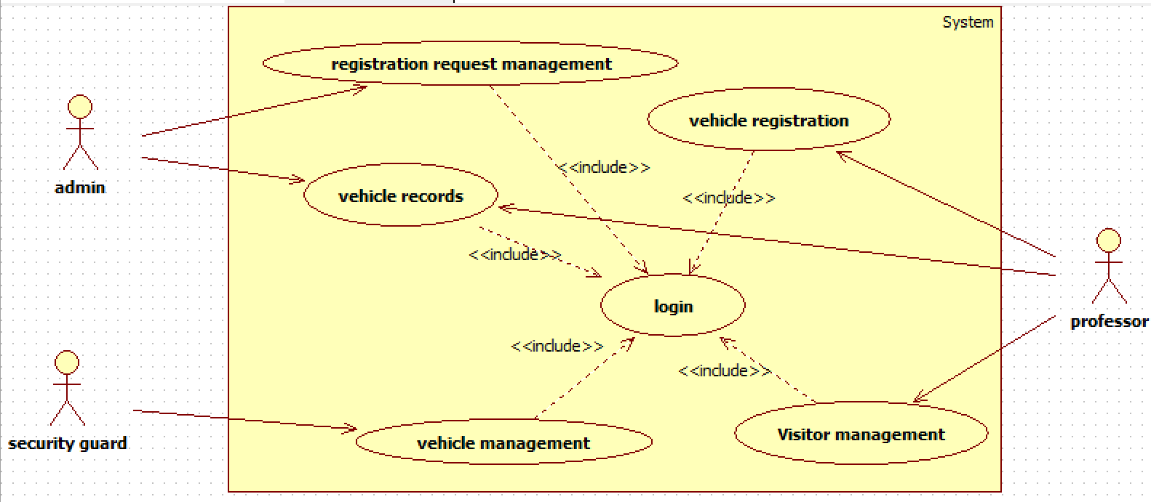

USE CASE TEMPLATE
Use Case ID: | 1
Use Case Name: | Vehicle Registration
Created By: | G. Lokesh Varma | Last Updated By: | G. Lokesh Varma
Date Created: | 17-02-2024 | Date Last Updated: | 04-04-24

Actors: | Admin
Description: | This use case involves the registration of vehicles by professors.
Preconditions: | Professor must be logged in.  Professor privileges are required for vehicle registration.
Post conditions: | Registration request is passed.
Normal Flow: | - I. Professor selects the "vehicle registration" option.  - II. Professor enters vehicle details such as:  - - Name  - - Vehicle number  - - Licence number  - - University ID, mail ID  - - Vehicle type  - - RC copy of vehicle.  - IV. After submitting the form, it goes to the registration request section.
Alternative Flows: | I. If the user provides an invalid or empty fields:  2.1. The system notifies the user about the invalid fields.  2.2. Resume normal flow from step IV.
Exceptions: | Incomplete information provided during registration.  Incorrect vehicle details.
Includes:
Priority: | High
Frequency of Use: | Rare
Business Rules: | Only professors can initiate vehicle registration.  A vehicle can only be registered once.
Assumptions: | The professor has valid login credentials.

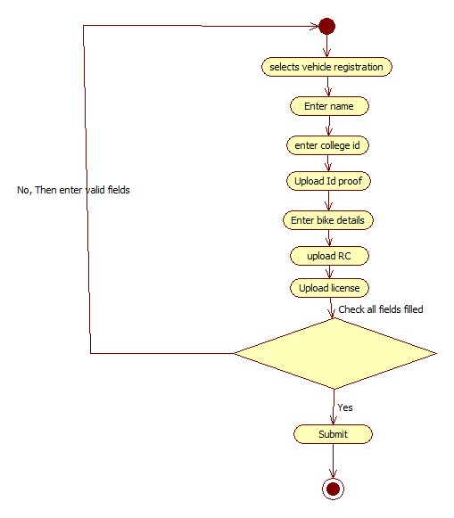

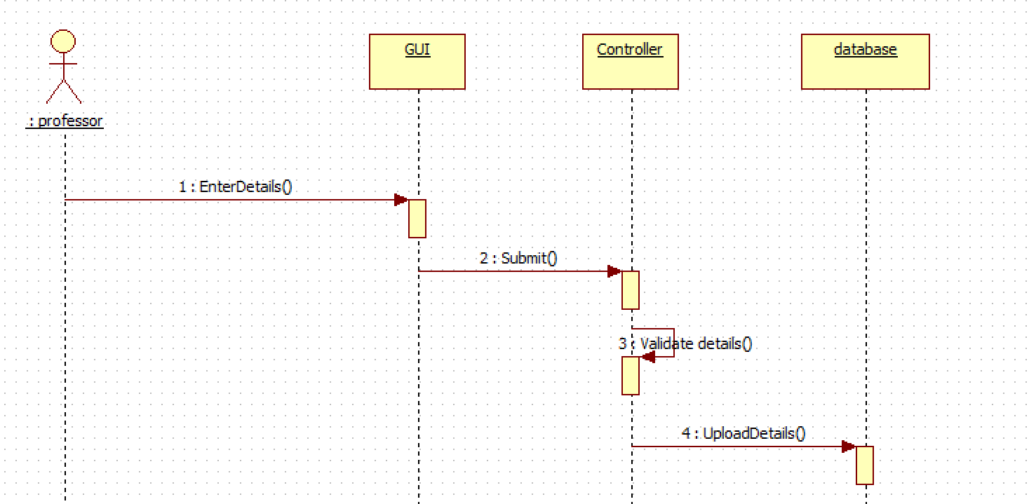

USE CASE TEMPLATE
Use Case ID: | 2
Use Case Name: | Registration request management
Created By: | V. Madhava Babu | Last Updated By: | G. Lokesh Varma
Date Created: | 17-02-2024 | Date Last Updated: | 04-04-24

Actors: | Admin
Description: | This use case involves the admin managing vehicle registration requests, reviewing and either approving or denying them, with corresponding notifications sent to the users.
Preconditions: | Admin must be logged into the system.  Vehicle registration requests should be pending.
Post conditions: | Vehicle registration is either approved or denied, and users receive notifications.
Normal Flow: | - I. Admin selects the "Registration Request Management" option.  - II. System displays a list of pending vehicle registration requests.  - III. Admin selects a specific request to review.  - IV. Admin reviews the details provided in the registration request.  - V. Admin approves or denies the registration request.
Alternative Flows: | None
Exceptions:
Includes: | Vehicle Registration (for users to initiate registration requests).
Priority: | High
Frequency of Use: | Frequent
Business Rules: | Only admins can manage and approve/deny registration requests.
Assumptions: | The user has valid login credentials

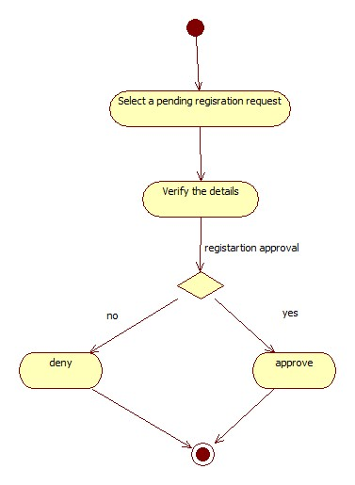

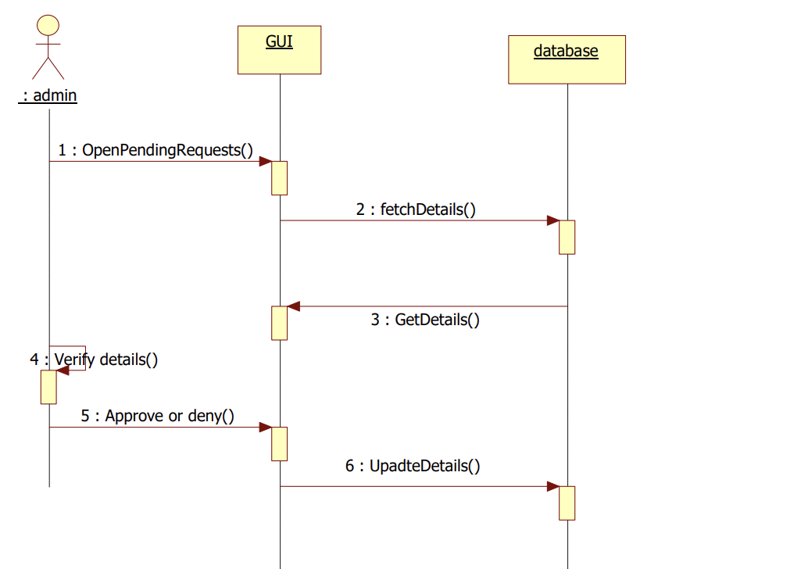

USE CASE TEMPLATE
Use Case ID: | 3
Use Case Name: | Vehicle records
Created By: | G. Lokesh Varma | Last Updated By: | G. Lokesh Varma
Date Created: | 17-02-2024 | Date Last Updated: | 04-04-24

Actors: | Admin, Professor
Description: | This use case involves accessing vehicle records for both users and admins
Preconditions: | User must be logged into the system.
Post conditions: | Vehicle records are viewed
Normal Flow: | - I. User selects the "Vehicle Records" option.  - II. Admin can enter vehicle details or searches for specific records such as ID.  - III. Admins can access records of any vehicle.  - IV. Professors can access their own vehicle records.  - V. Professors can also see their respective visitor vehicle records
Alternative Flows: | I. If no vehicle records are found for the specified criteria:  1.1. The system notifies the user about the absence of records.  1.2. User is prompted to refine the search criteria.  1.3. Resume normal flow from step II.
Exceptions: | No vehicle records found for the specified criteria.
Includes:
Priority: | Medium
Frequency of Use: | Regular
Business Rules: | Admins can access any vehicle record.  Professors can only access their own vehicle records.
Assumptions: | The user has valid login credentials

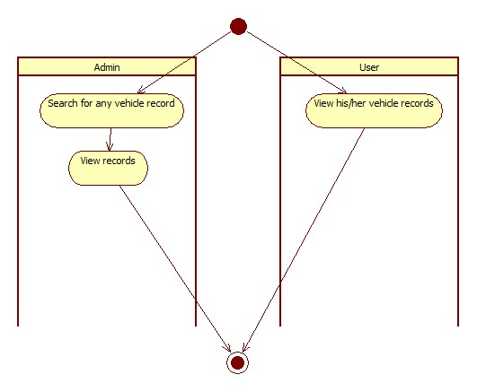

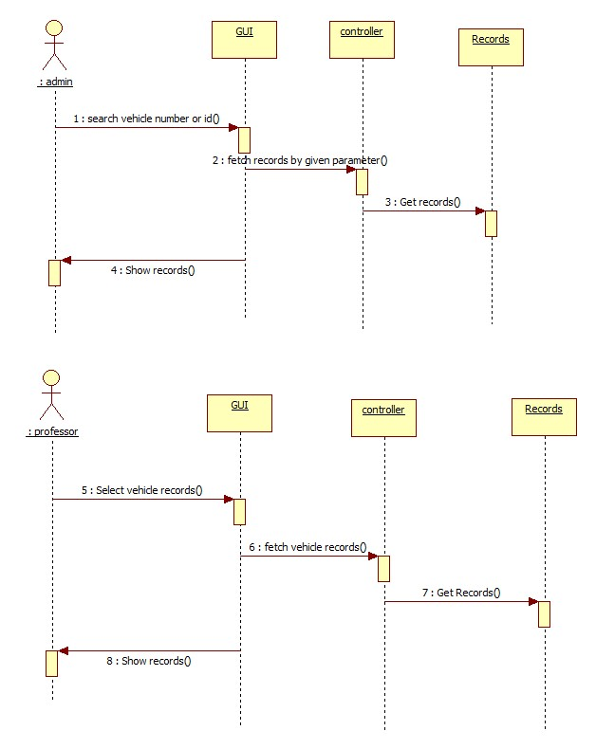

USE CASE TEMPLATE
Use Case ID: | 4
Use Case Name: | Vehicle management
Created By: | V. Madhava Babu | Last Updated By: | G. Lokesh Varma
Date Created: | 17-02-2024 | Date Last Updated: | 04-04-24

Actors: | Security Guard
Description: | This use case involves the security guard managing the entry of detected vehicles, allowing access for registered vehicles, and collecting information for unregistered ones, with number plate detection performed by technology like YOLO (You Only Look Once).
Preconditions: | Security guard must be logged into the system.  Vehicle number must be detected before managing the Vehicles.  Visitor form is submitted.
Post conditions: | Access is granted for registered vehicles, and information is collected for unregistered ones.
Normal Flow: | - I. After Security guard logged in to the system.  - II. The system, using technology like YOLO, detects the number plate of the approaching vehicle.  - III. If the vehicle is registered, the system shows it is registered you can choose in or out.  - IV. If the vehicle is not registered, the system prompts the security guard to enter the visitor's name and purpose allowed or not allowed and in or out.  - V. If the vehicle is not registered and it is a visitor given by visitor form, the system shows he is a visitor allow wait for professor’s approval.  - VI. Security guard enters visitor information.  - VII. System logs entry details for the unregistered vehicle.
Alternative Flows: | If the number plate detection fails or is inaccurate, the security guard may manually enter the vehicle details.
Exceptions: | Invalid or unreadable number plate.  Information entered is incomplete.
Includes: | None
Priority: | High
Frequency of Use: | Frequent
Business Rules: | Security guards are responsible for managing vehicle entry.  Unregistered vehicles may require manual entry of visitor information if the automated number plate detection fails.
Assumptions: | The number plate detection technology (e.g., YOLO) is functional.  Security guards are trained to handle the manual entry process if needed.

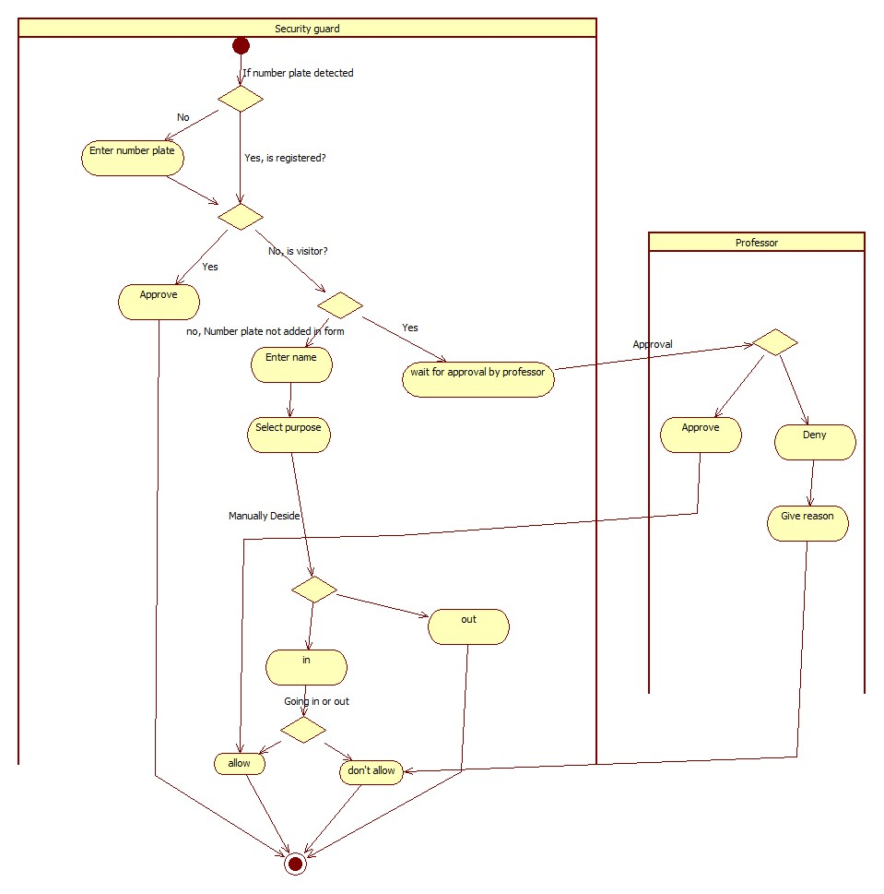

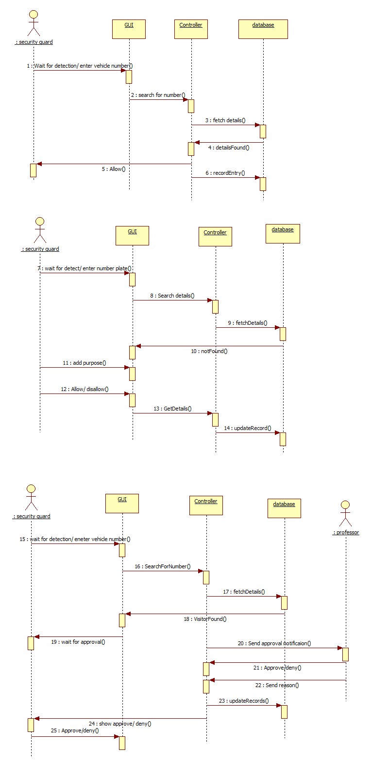
USE CASE TEMPLATE
Use Case ID: | 5
Use Case Name: | Visitor management
Created By: | V. Madhava Babu | Last Updated By: | G. Lokesh Varma
Date Created: | 17-02-2024 | Date Last Updated: | 04-04-24

Actors: | Professor
Description: | This use case involves professors submitting visitor forms to streamline visitor entry.
Preconditions: | Professor must be logged into the system.
Post conditions: | Visitor details are uploaded.  System notifies for approval if visitor comes.  System notifies if the visitor enters or leaves.
Normal Flow: | - Professor selects the "Visitor Form" option.  - Professor enters visitor details including the vehicle number.  - If visitor is arrived, System notifies the intended professor for visitor approval.
Alternative Flows: | I. Incomplete Information Provided:  1.1 If the professor submits the visitor form with incomplete information, the system prompts the professor to provide the missing details.  1.2 The professor revises the visitor form, filling in the necessary information.  1.3 After completing the form, the professor submits it again.  1.4 The system validates the form and proceeds with the normal flow, notifying the intended professor if the visitor arrives.
Exceptions: | Incomplete information provided in the visitor form.
Includes:
Priority: | Medium
Frequency of Use: | Occasional
Business Rules: | Professors are responsible for submitting visitor forms.
Assumptions:

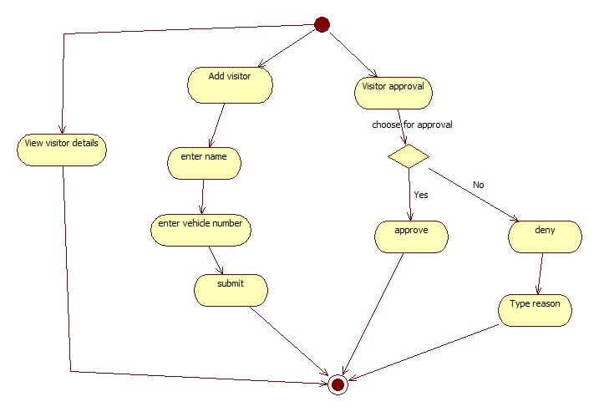

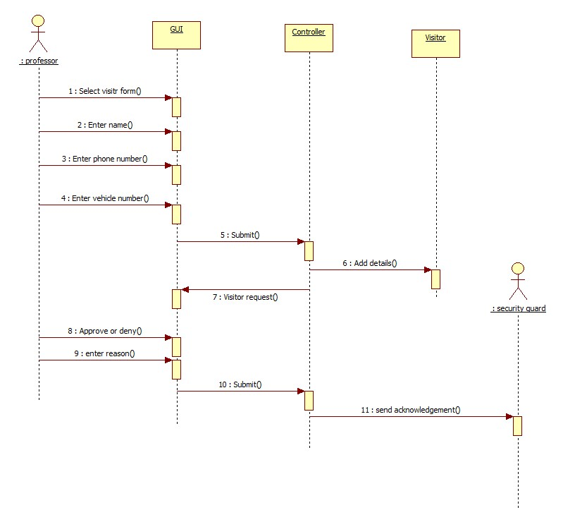

USE CASE TEMPLATE
Use Case ID: | 6
Use Case Name: | Login
Created By: | G. Lokesh Varma | Last Updated By: | G. Lokesh Varma
Date Created: | 17-02-2024 | Date Last Updated: | 04-04-24

Actors: | Admin, Professor, Security Guard
Description: | This use case involves logging into the Vehicle Management System.
Preconditions: | User must have valid login credentials.
Post conditions: | User is successfully logged into the system.
Normal Flow: | - I. User enters username and password.  - II. If the user doesn't have login credentials, they must register.  - III. Admin and security have their own private passwords.  - IV. System verifies the credentials.  - V. If valid, user is granted access to the system.
Alternative Flows: | - Forgot password functionality is used for password recovery.
Exceptions: | Invalid username or password.
Includes: | All other use cases
Priority: | High
Frequency of Use: | Every use of the system
Business Rules: | Only registered users can log in.
Assumptions: | Users have valid login credentials.

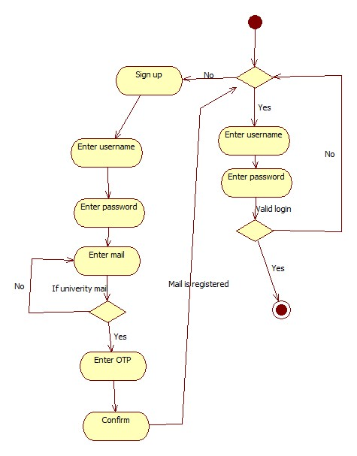

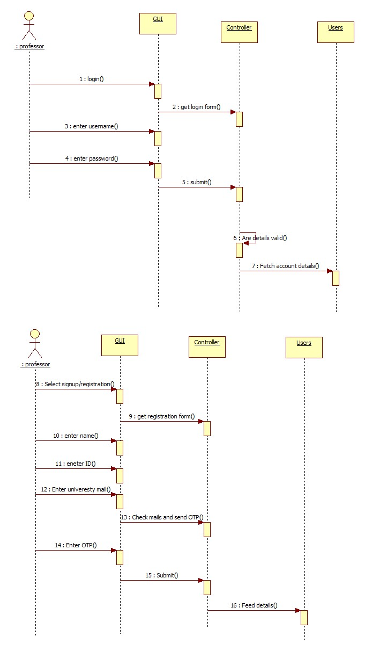

USE CASE TEMPLATE
Use Case ID:
Use Case Name:
Created By: |  | Last Updated By:
Date Created: |  | Date Last Updated:

Actors:
Description:
Preconditions:
Post conditions:
Normal Flow:
Alternative Flows:
Exceptions:
Includes:
Priority:
Frequency of Use:
Business Rules:
Assumptions:

